3.Discuss how you will organize your time for the rest of the project.(200 words)

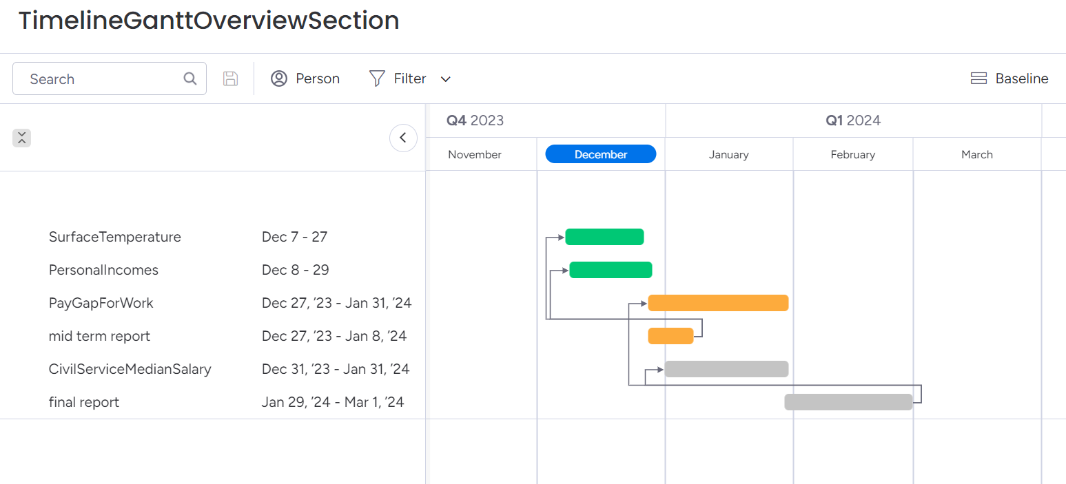

Graph - Gantt graph

As seeing in this graph, the green bars are the extensions that I have finished, the yellow bars are the working ones, and the grey bars are the work have not yet started.

After the mid term, I will focus on the working extensions and ready to do the final report.

If all goes well, considering that the final report deadline is March 8th, I will complete the project on March 1st. I'll spend the next remainging days doing the review and final submission.